|  |  |
| --- | --- |
| C:\Users\Touseef\Desktop\download (1).png | **Department of Electrical and Computer Engineering** |
| **LAB # 2 Introduction to SmartPRO 5000u** |

**Student Name:**  Muhammad Haseeb **Reg. No:** 200718 **Section:** BEEE-5A

**Objective:** Familiarize students with ATMEL 8051 IC and RIMS trainer kit

Familiarization with Keil μVision ,SmartPRO 5000U and proteus

**LAB ASSESSMENT:**

|  |  |  |  |  |  |
| --- | --- | --- | --- | --- | --- |
| **Attributes** | **Excellent**  **(5)** | **Good**  **(4)** | **Average**  **(3)** | **Satisfactory**  **(2)** | **Unsatisfactory**  **(1)** |
| **Ability to Conduct Experiment** |  |  |  |  |  |
| **Ability to assimilate the results** |  |  |  |  |  |
| **Effective use of lab equipment and follows the lab safety rules** |  |  |  |  |  |

Total Marks: 15 Obtained Marks :

**LAB REPORT ASSESSMENT:**

|  |  |  |  |  |  |
| --- | --- | --- | --- | --- | --- |
| **Attributes** | **Excellent**  **(5)** | **Good**  **(4)** | **Average**  **(3)** | **Satisfactory**  **(2)** | **Unsatisfactory**  **(1)** |
| **Data presentation** |  |  |  |  |  |
| **Experimental results** |  |  |  |  |  |
| **Conclusion** |  |  |  |  |  |

Total Marks: 15 Obtained Marks:

Date: Signature:

**Introduction**

A microcontroller is similar to a basic computer with even similar parts such as processor , memory and hardware peripherals (I/O).Unlike a computer all these attributes are integrated on a single chip.A microcontroller can execute one task whose parameters are set on software by coding.The 8051 microcontroller has 40 pins which are programmable and will be used in this experiment.

**Objectives**

* Familiarize students with ATMEL 8051 IC and RIMS trainer kit
* Familiarization with Keil μVision, SmartPRO 5000u and proteus

**Procedure**

Keil μVision is used to write the code which consists of the instructions which are later integrated on the microcontroller.Make sure that ATMEL 89c51 microcontroller is selected and the frequency is set to 11.0592Mhz .To create a hex file turn on the option and select build target.Make sure the hex file is saved and now open proteus.Select AT89c51 chip and make the circuit as follows

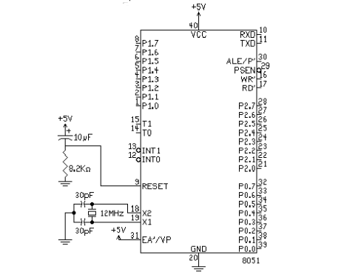

Double click on the chip and again set clock frequency to 11.0592Mhz and upload the hex file we previously created.Now we can simulate and validate our code before burning it on the microcontroller.

Lastly, burn the code on the microcontroller using SmartPRO 5000U and obtain similar results on the hardware.

**Results**

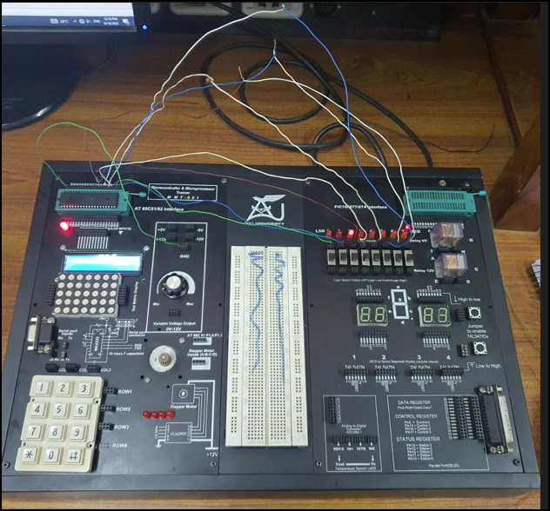

**TASK 2 (HomeTask)**

**Question:**

Generate the following sequences on LEDs:

1. Blinking LEDs towards right

2. Blinking LEDs towards left

**Code with EXPLANATION**

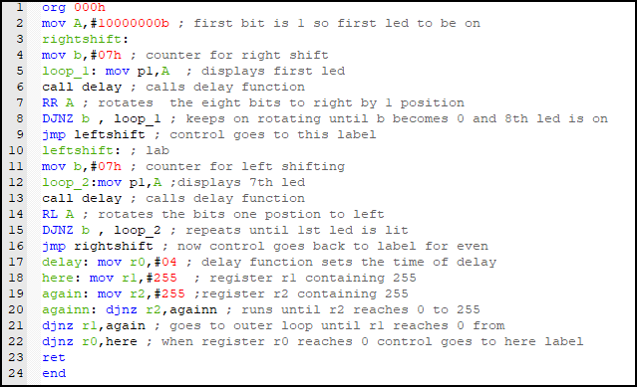

**Proteus Simulation:**

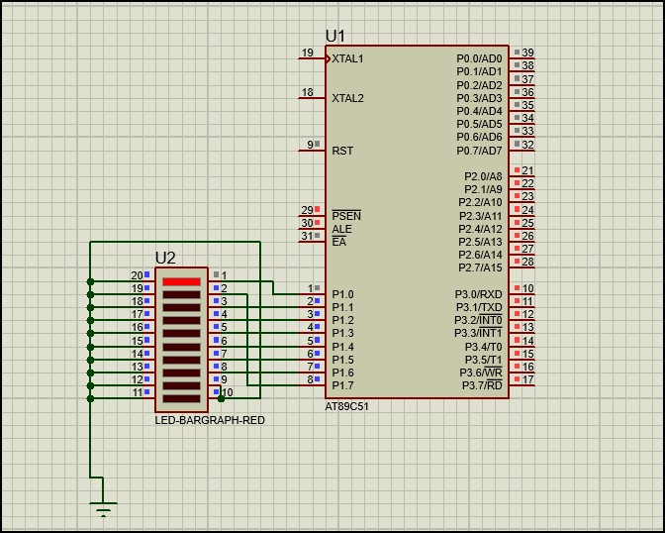

**Video Demo :** <https://vimeo.com/753920338>

**CONCLUSION**

Learned to program a microcontroller by burning a hex code using SmartPRO 5000 and connecting it to the trainer and leds with correct Pin configuration to match simulation and hardware results.